**VIVEKANAND EDUCATION SOCIETY’S INSTITUTE OF TECHNOLOGY**

**(An Autonomous Institute Affiliated to University of Mumbai)**

**Department of Computer Engineering**



Project Report on

BlockChain based Medicine Ordering System using IVR

Submitted in partial fulfillment of the requirements of the degree

**BACHELOR OF ENGINEERING** IN **COMPUTER ENGINEERING**

By

**Lintomon ChirakkaraD17A/08**

**Aditya Kushwaha D17A/35**

**Chinmay Phapale D17A/46**

**Vedant Talwalkar D17A/61**

**Project Mentor**

Mr.Richard Joseph

**(AY 2024-25)**

**VIVEKANAND EDUCATION SOCIETY’S INSTITUTE OF TECHNOLOGY**

**(An Autonomous Institute Affiliated to University of Mumbai)**

**Department of Computer Engineering**



# CERTIFICATE

This is to certify that the Mini Project entitled **“BlockChain based Medicine Ordering System using IVR”** is a bonafide work of **Lintomon Chirrakara(D17A/08)**,**Aditya Kushwaha(D17A/35),Chinmay Phapale(D17A/46), Vedant Talwalkar(D17A/61)** submitted to the University of Mumbai in partial fulfillment of the requirement for the award of the degree of **“Bachelor of Engineering”** in **“Computer Engineering” .**

## (Prof.Richard Joseph)

Mentor

## (Prof. Dr. Nupur Giri) (Prof. Dr. J.M. Nair)

Head of Department Principal

# Project Approval

This Mini Project entitled **“BlockChain based Medicine Ordering System using IVR”** by **Lintomon Chirrakara(D12A/08)**,**Aditya Kushwaha(D12A/35),Chinmay Phapale(D12A/46),Vedant Talwalkar(D12A/61)** is approved for the degree of **Bachelor of Engineering** in **Computer Engineering.**

**Examiners**

**1………………………………………**

(Internal Examiner Name & Sign)

## 2…………………………………………

(External Examiner name & Sign)

Date:

Place:

**Declaration**

We declare that this written submission represents our ideas in our own words and where others' ideas or words have been included, we have adequately cited and referenced the original sources. We also declare that we have adhered to all principles of academic honesty and integrity and have not misrepresented or fabricated or falsified any idea/data/fact/source in our submission. We understand that any violation of the above will be cause for disciplinary action by the Institute and can also evoke penal action from the sources which have thus not been properly cited or from whom proper permission has not been taken when needed.

| -----------------------------------------  (Lintomon Chirrakara D17A/08) | -----------------------------------------  (Aditya Kushwaha D17A/35) |
| --- | --- |
| -----------------------------------------  (Chinmay Phapale D17A/46) | -----------------------------------------  (Vedant Talwalkar D17A/61) |

Date:

**ACKNOWLEDGEMENT**.

We are thankful to our college Vivekanand Education Society’s Institute of Technology for considering our project and extending help at all stages needed during our work of collecting information regarding the project.

It gives us immense pleasure to express our deep and sincere gratitude to Assistant Professor **Mr. Richard Joseph (Project Guide)** for his kind help and valuable advice during the development of project synopsis and for her guidance and suggestions.

We are deeply indebted to Head of the Computer Department **Dr.(Mrs.) Nupur Giri** and our **Principal Dr. (Mrs.) J.M. Nair** , for giving us this valuable opportunity to do this project.

We express our hearty thanks to them for their assistance without which it would have been difficult in finishing this project synopsis and project review successfully.

We convey our deep sense of gratitude to all teaching and nonteaching staff for their constant encouragement, support and selfless help throughout the project work. It is a great pleasure to acknowledge the help and suggestion, which we received from the Department of Computer Engineering.

We wish to express our profound thanks to all those who helped us in gathering information about the project. Our families too have provided moral support and encouragement several times.

**Index**

| Chapter No. | | Title | Page Number |
| --- | --- | --- | --- |
| List of Abbreviations | | | VII |
| List of Figures | | | VIII |
| List of Tables | | | IX |
| Abstract | | | X |
| 1 | | Introduction | 1 |
|  | 1.1 | Introduction |  |
|  | 1.2 | Motivation |  |
|  | 1.3 | Problem Definition |  |
|  | 1.4 | Relevance of the project |  |
|  | 1.5 | Methodology used |  |
|  | 1.6 | Relevance of the Project |  |
| 2 | | Literature Survey |  |
|  | 2.1 | Research Papers referred |  |
|  | 2.2 | Exiting Systems |  |
|  | 2.3 | Lacuna in the existing systems |  |
|  | 2.4 | Comparison with the existing system |  |
| 3 | | Requirements | 4 |
|  | 3.1 | Proposed model |  |
|  | 3.2 | Functional Requirements |  |
|  | 3.3 | Non-Functional Requirements |  |
|  | 3.4 | Hardware, Software, Technology and tools utilized |  |
|  | 3.5 | Technology and Tools utilized |  |
|  | 3.6 | Constraints of working |  |
| 4 | | Proposed Design | 6 |
|  | 4.1 | Block Diagram of the proposed system |  |
|  | 4.2 | Detailed Design |  |
| 5 | | Results and Discussions | 8 |

| 6 | | Plan of action for the next semester | 18 |
| --- | --- | --- | --- |
| 7 | | Conclusion | 20 |
| 8 | | References | 25 |
| 9 | | Appendix |  |
|  | a | List of Figures |  |
|  | a | List of tables |  |
| Paper Draft | | | |
| Plagiarism report | | | |
| Project review sheet | | | |

**TABLE OF FIGURES :**

| **Sr.no** | **TITLE** | **Page Number** |
| --- | --- | --- |
| 1 | BLOCK DIAGRAM | 20 |
| 2 | DETAILED DESIGN | 23 |
| 3 | CHAINCODE IMPLEMENTATION | 24 |
| 4 | HOME PAGE | 24 |
| 5 | MEDICINE DETAILS | 24 |
| 6 | FETCH MEDICINE VIA CATEGORY | 25 |
| 7 | CHATBOT | 25 |
| 8 | OCR TO EXTRACT MEDICINE NAMES | 25 |

**Chapter 1 : Introduction**

**1.1 Introduction**

A large portion of India's population, especially the elderly and rural residents, faces limited access to healthcare and essential medications due to transportation challenges and low digital literacy. The World Health Organization reports that 90 million people in India struggle to obtain necessary medicines. Additionally, counterfeit drugs and a lack of transparency in the supply chain threaten patient safety, with up to 10% of medicines in low-income countries being substandard or falsified. Data breaches also compromise health systems, with nearly 60% of healthcare organizations affected in 2023.

To address these issues, we propose the Interactive Voice Response-Based Medicine Ordering System using Blockchain (IMOSB). This solution integrates IVR technology, allowing patients to order medications via voice commands, and blockchain, which ensures transparency and security in the ordering process. Prescriptions are verified by doctors or hospitals, and transactions are immutably recorded on the blockchain, creating a secure and accessible system for all users, especially in remote areas.

**1.2 Motivation**

The motivation behind the Interactive Voice Response-Based Medicine Ordering System utilizing Blockchain (IMOSB) stems from the critical need to enhance healthcare accessibility and security in underserved populations. Traditional healthcare systems often fail to accommodate the unique challenges faced by rural residents and the elderly, including limited access to digital technologies and literacy barriers. By leveraging an IVR system, we aim to provide a user-friendly interface that allows individuals to order medications without requiring advanced technical knowledge or smartphones.

Moreover, the increasing prevalence of counterfeit medications poses a significant risk to patient safety. Our project seeks to establish a robust framework that not only facilitates secure medication ordering but also ensures the authenticity of prescribed drugs. The integration of blockchain technology serves to create a transparent and verifiable supply chain, fostering trust among patients, healthcare providers, and pharmacists. This innovative approach aims to bridge the accessibility gap in healthcare while addressing the pressing need for improved safety and integrity in the medication distribution process.

**1.3 Problem Definition**

The healthcare landscape in rural areas and among the elderly is characterized by significant barriers to accessing essential medications, primarily due to limited healthcare facilities, transportation challenges, and low digital literacy. These barriers prevent many individuals from effectively ordering and obtaining prescribed medicines. Additionally, the rise of counterfeit drugs in the supply chain poses a severe threat to patient safety, as traditional systems lack transparency and are vulnerable to fraud.

Current methods of prescription verification are often inefficient, leading to concerns about the legitimacy of medications ordered by patients who may not possess the technical skills required for digital platforms. This results in increased risks of receiving substandard or falsified drugs, jeopardizing patient health outcomes.

To address these issues, there is a need for a comprehensive solution that simplifies the medication ordering process while ensuring the authenticity of prescriptions and enhancing transparency within the supply chain. The Interactive Voice Response-Based Medicine Ordering System utilizing Blockchain (IMOSB) aims to tackle these challenges by providing a secure, accessible platform that enables patients to place orders using voice commands, while also leveraging OCR technology for effective prescription verification.

**1.4 Relevance of the Project**

The Interactive Voice Response-Based Medicine Ordering System utilizing Blockchain (IMOSB) is crucial in today’s healthcare landscape, particularly for underserved populations. By providing a user-friendly interface, it enables rural residents and the elderly to order medications without advanced technology or literacy skills, addressing significant access barriers.

Moreover, IMOSB tackles the rising concerns of counterfeit medicines and data breaches by integrating blockchain technology, enhancing the integrity and transparency of the medication supply chain. This innovation fosters trust among patients, healthcare providers, and pharmacists, ensuring patient safety and data security.

**1.5 Methodology used**

By following the below steps, users can seamlessly navigate the Medicine Ordering System to fulfill their medication needs, receive personalized recommendations, and ensure a convenient and user-centric healthcare experience :

* **Registration and Authentication:**
  + Begin by registering on the platform, providing basic information such as name and phone number.
  + The phone number serves as a secure authentication method, ensuring a personalized connection and safeguarding against unauthorized access.
* **IVR-Based Medicine Ordering:**
  + Upon successful registration, users can initiate medication orders through the IVR system, powered by Twilio.
  + The IVR system intelligently authenticates users using their registered phone number and prompts them to specify the required medications using natural language processing.
* **Chatbot Assistance for Recommendations:**
  + Users may encounter uncertainty regarding suitable medications for specific symptoms. In such cases, they can interact with the chatbot for personalized recommendations.
  + The chatbot acts as a knowledgeable healthcare companion, providing tailored suggestions based on user symptoms and preferences.
* **Integration of IVR and Chatbot:**
  + The application seamlessly integrates the IVR system with Twilio and chatbot functionalities to provide a cohesive user experience.
  + Users can leverage both IVR and chatbot interfaces for placing orders, refining medication choices, and seeking assistance as needed.
* **Data Collection and Retrieval:**
  + The system gathers comprehensive information about medications, including names, side effects, compositions, and uses.
  + User input, such as health profiles and prescription uploads, is processed to extract relevant data for recommendation generation.
* **Displaying Recommendations:**
  + Based on user input and data retrieval, the system presents recommended medicines along with pertinent information.
  + Users receive details such as recommended dosage, alternative medicines, and availability to make informed decisions.
* **Feedback and Improvement:**
  + Continuous feedback collection from users helps enhance the recommendation system over time.
  + User suggestions and preferences are incorporated to refine the algorithm and improve the overall user experience.

**Chapter 2: Literature Survey**

**2.1 Research Papers referred**

In [1], it is discussed that while traditional IVR systems offer cost reduction and efficiency in call centers, their reliance on programmers for modifications hinders flexibility. This paper proposes a dynamic IVR platform designed for non-programmers to manage and modify IVR scenarios, potentially reducing costs, improving customer satisfaction, and increasing efficiency through its user-friendly interface and dynamic functionality. However, further research is needed to evaluate its real-world effectiveness and address potential risks like user frustration or difficulty accessing help.

The paper [2] introduces a Blockchain-Powered Parallel Healthcare System (PHS) framework, integrating blockchain with the ACP (Artificial systems, Computational experiments, Parallel execution) approach to enhance healthcare operations. It uses a consortium blockchain to connect hospitals, patients, health bureaus, and healthcare communities. This setup allows healthcare providers and patients to control data access, with only authorized participants able to review or modify records.Smart contracts on the blockchain enable secure, automated data sharing, regulating access rights and maintaining an audit trail to safeguard EHRs and privacy. A prototype system for gout diagnosis and treatment, deployed at a Qingdao hospital, demonstrates the framework’s capacity to securely manage patient data and update it in real time, while parallel execution enables doctors to refine treatment plans based on computational insights. The paper also explores potential expansions to decentralized healthcare organizations, counterfeit drug prevention, patient monitoring, and predictive healthcare research.

The paper [3] proposes a personalized interactive voice response (PIVR) system similar to that of [1], but here they address the limitations of traditional IVR systems. PIVR utilizes speech recognition and user data to greet customers by name, offer personalized menus, and allow customization. The system is built using the Microsoft Speech Application Software Development Toolkit (SASDK), ASP.NET, and a database. Analysis of speech recognition showed a negative correlation between clean and distorted speech and a positive correlation between utterances from different speakers. The authors believe PIVR offers a more customer-friendly and efficient self-service experience compared to traditional IVR systems. However, more research is needed to evaluate its effectiveness in real-world settings. In these research papers, the use of and current technological advancements in the field of IVR were understood.

**2.2 Exiting Systems**

1. **1mg:**

1mg provides a comprehensive range of digital healthcare services in India, including wellness products, telemedicine, online medication orders, diagnostics, and health record management. The platform allows users to upload handwritten doctor’s prescriptions and offers details about medications and general healthcare services. With a strong emphasis on accessibility, 1mg has established itself as a reliable source for medication and health information.

1. **MediSearch:**

MediSearch is a web-based resource that assists users in making informed health decisions. It provides detailed information on medications, their applications, and possible side effects. Its innovative chatbot feature addresses users' health-related inquiries, delivering follow-up responses to ensure clarity and guidance.

1. **Apollo 24/7:**

Apollo 24/7 covers a wide spectrum of healthcare services, from online medicine ordering and symptom-based health information to lab test bookings and direct doctor appointments. It offers users comprehensive healthcare access but lacks a chatbot for general advice. The platform primarily serves users in urban and semi-urban areas due to its reliance on internet connectivity for most services.

1. **Pharmeasy:**

Pharmeasy allows users to order medicines online and provides options for booking lab tests with a valid prescription. While it supports medicine ordering through the app, it requires users to have an internet connection for most services, including registration. Pharmeasy does not currently offer a chatbot feature for general medical inquiries or symptom-based advice.

1. **TrueMeds:**

TrueMeds is a newer application in the market that facilitates online medicine orders and offers a calling service for medicine delivery. However, users must register on the app and have an internet connection to access services. Unlike some platforms, TrueMeds does not include a chatbot for health inquiries based on symptoms or general health advice.

**2.3. Lacuna in the existing systems**

It's evident from a survey of other systems whose functionality matches ours that every system has some flaws which our system intends to address.Understanding these limitations and gaps is essential for the development of the 'IVR based medications' personalized recommendation system:

**1. Lack of Personalization:**

While current systems frequently offer broad information about drugs and illnesses, they might not provide specific advice depending on the individual user's requirements, medical background, and unique symptoms.

**2. Inability to Prescribe Medications**:

One important function our system attempts to address is the inability of these platforms to prescribe or recommend particular medications to users based on their symptoms or uploaded medical documents.

**3. Limited Interaction**:

Although these platforms allow users to search for information, there isn't much opportunity for two-way communication. Our system offers real-time guidance and improves user engagement by introducing an Interactive Voice Response (IVR) system.

**4. Poor Integration**:

In many current platforms, the integration of features like symptom analysis, medication information, and personalized recommendations are either incomplete or separated. Our system aims to provide a thorough and unified solution.

**5. Research Gap**:

To deliver an accurate and interactive healthcare experience, there is an absence in the research and development of systems that effectively combine medication information, symptom analysis, and IVR capabilities. Our system fills this research gap by providing a novel approach to these requirements.

In conclusion, personalization, prescription capabilities, interaction, integration, and a lack of research in comprehensive healthcare solutions are the main drawbacks of current systems like 1mg and MediSearch. Our system aims to close these gaps by offering an interactive, user-centered platform for improved healthcare administration.

**2.4 Comparison with the existing system**

|  | **Our System** | **1mg** | **Medisearch** |
| --- | --- | --- | --- |
| Medication Ordering | ✓ Allows users to order medications through IVR technology | ✓ Offers online medicine ordering service | ✗ Provides information about medications only |
| User Registration | ✓ Provides a user registration process for personalized interactions | ✓ Requires user registration for ordering and other services | ✗ Does not require user registration for accessing information |
| Interactive Voice Response (IVR) | ✓ Integrates IVR for seamless user engagement | ✗ Lacks IVR integration | ✗ Lacks IVR integration |
| Personalization | ✓ Utilizes user profiles and medical histories for personalization | ✓ Offers personalized recommendations based on user history | ✗ Does not offer personalized recommendations |
| Medication Information | ✓ Offers information about medication | ✓ Provides detailed information about medications | ✓ Provides comprehensive information about medications |

**Chapter 3: Requirements**

**3.1 Proposed model**

Our system enables patients, or individuals acting on their behalf, to order medicines via an Interactive Voice Response (IVR) system. This IVR system allows users, especially those in rural areas or without smartphones, to place orders by submitting required details, including prescriptions if necessary. Once the IVR collects all the required data, such as the medicine details and prescription, it transfers this information to the Fabric Client, which initiates a blockchain-based transaction. The Fabric Client acts as the central interface, connecting the user with the blockchain network and facilitating the interaction between different actors such as doctors, pharmacists, and delivery partners.

The Fabric Client then sends the prescription to the Concerned Doctor/Hospital for validation. The doctor/hospital checks whether the prescription is valid, ensuring the digital signature is legitimate, the prescription has not expired, and the requested dosage is appropriate. Once validated, the Fabric Client creates a transaction including medicine details and prescription confirmation. This transaction is sent to the endorser peers, which simulate the transaction using the chaincode to verify business logic. Once endorsed, the transaction is forwarded to the Orderer Peers, who organize it into blocks and broadcast these blocks to all Committer Nodes, ensuring the transaction is securely added to the blockchain.

After confirming the transaction’s success, the Fabric Client coordinates with the Pharmacist and the Delivery Partner. The Pharmacist verifies the medicine order and notifies the Fabric Client about its availability. The Delivery Partner is then informed to pick up the medicines, ensuring proper packaging and timely delivery to the patient. Once the delivery is completed, the delivery status is updated in the blockchain, maintaining a full transaction history. This decentralized approach ensures secure, transparent, and efficient medicine ordering and delivery for all stakeholders involved.

In this section, we explain how the IVR-based medicine ordering system, now enhanced with Hyperledger Fabric, was designed and implemented. We walk through the structure of the system, the key participants like the user, pharmacist, and doctor, and how they interact with each other. The use of Hyperledger Fabric adds an extra layer of security and trust by ensuring that orders and sensitive data are handled transparently and securely through smart contracts and a decentralized ledger. We’ll also cover how the system processes everything—from a user placing an order using simple voice commands, to verifying prescriptions, and finally registering the transaction in the blockchain. Along the way, we’ll discuss how we’ve managed data, ensured security, and set up the system, giving a clear understanding of the steps involved in building and running this platform.

**3.2 Functional Requirements**

The functional requirements of our project are as follows:

1. The system should provide a user registration process.
2. The system must incorporate Interactive Voice Response (IVR) for user interaction.
3. The system must finalize orders only after successful checks.
4. The system should emphasize accessing and organizing medical data from various sources.
5. The system must undergo rigorous model selection and training to ensure high accuracy.
6. The system should demonstrate the ability to interact like a human.
7. The system must maintain high standards of accuracy and reliability.

**3.3.Non-Functional Requirements**

The non-functional requirements of our project are as follows:

1. Able to respond promptly to user interactions and handle a large number of concurrent users efficiently.
2. Provide a user-friendly interface and support accessibility features
3. Must be available at all times and capable of recovering quickly from failures.
4. Able to accommodate a growing user base and increasing data volume without sacrificing performance.
5. Must be well-documented and adhere to coding standards for ease of maintenance and future enhancements.

**3.4.Hardware & Software Requirements**

## Hardware Requirements:

## Processor:A good processor that will be efficiently utilized in training the model.

## Storage: Storage is required to store the training and testing data.

## Memory: A memory of 16GB would be sufficient for the tasks.

## Internet connection: It would be necessary to install various libraries used for the project

## 

## 

## Software Requirements:

### Python (3.x): The server for the application is built using Python and many Python libraries.

### Flask: Flask is required to develop the web application's backend (handling API calls).

### OpenCV: OpenCV is used for image processing in video streams and blur detection of images

**3.5.Technology and Tools utilized**

| **No.** | **Package** | **Version** |
| --- | --- | --- |
| 1 | Flask | 2.3.2 |
| 2 | OpenCV-Python | 4.8.0.74 |
| 3 | Transformers | 0.0.1 |
| 4 | OS-Sys | 2.1.4 |
| 5 | Pillow | 10.0.0 |
| 6 | Hugging Face | 1.11.1 |
| 7 | Flutter | 3.16.2 |
| 8 | Twilio | Any |

**3.6.Constraints of working**

**1. Hardware Limitations:** The system's performance may be constrained by the processing power, memory, and storage capacity of the selected hardware, potentially impacting its ability to handle large volumes of data or concurrent user interactions efficiently.

**2. Dependency on External Libraries:** Reliance on specific software libraries introduces constraints related to compatibility, version dependencies, and maintenance, requiring careful consideration to ensure system stability and functionality.

**3. Integration Complexity**: Integrating IVR technology with other system components may present challenges in compatibility and interoperability, necessitating thorough planning and testing to address potential integration issues.

**4. Data Security and Privacy**: Compliance with data security regulations imposes constraints on implementing robust security measures to protect sensitive user information and transactions, including encryption and access control.

**5. Scalability Requirements**: Meeting the system's scalability requirements involves ensuring that the architecture and infrastructure can effectively handle a growing user base and increasing data volume without sacrificing performance or responsiveness.

**6. Training and Model Selection**: Rigorous model selection and training processes for machine learning models may impose constraints in terms of time, computational resources, and expertise, requiring careful allocation of resources and domain-specific knowledge

**Chapter 4: Proposed Design**

**4.1 Block Diagram of the proposed system**

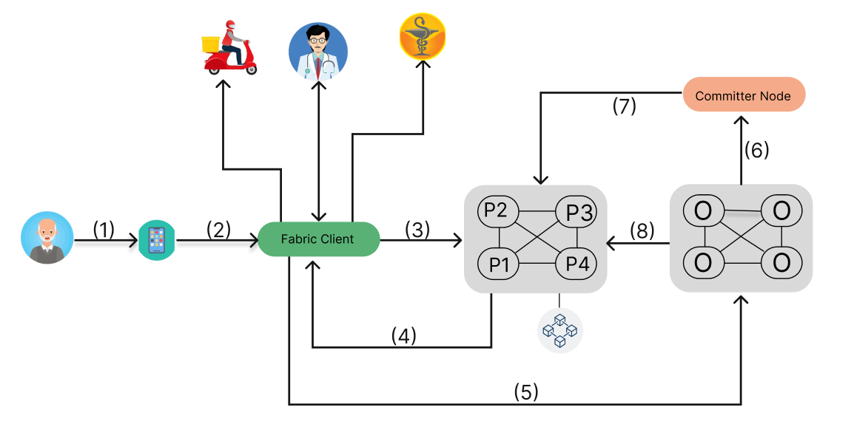

*Fig 4.1:-Block diagram*

The workflow begins when a patient or customer uses the mobile application **(1)** to **place an order** or request a prescription. The application then sends the request to the **Fabric Client** **(2)**, which acts as an intermediary between the application and the Hyperledger Fabric network.

Next, the Fabric Client forwards the **transaction proposal** to the network peers (P1, P2, P3, P4) for validation **(3)**. These peers evaluate the proposal, and once validated, they return an **endorsement response** to the Fabric Client **(4)**. Following this, the Fabric Client sends the **endorsed transaction** to the Orderer Nodes **(5)**. The Orderer Nodes are responsible for organizing transactions into blocks and ensuring that they follow the proper sequence in the blockchain.

Meanwhile, the doctor plays a critical role in approving the patient's medication request by verifying or prescribing the necessary medicines. Once the doctor confirms, the request moves to the pharmacist, who verifies the prescription and prepares the medicines for delivery. The delivery partner is then responsible for ensuring that the medications reach the patient.

After the peers' responses are collected and the transaction passes through the Orderer Nodes, the transaction moves to the ordering service, which checks if the transaction meets the network's endorsement policy **(6)**. If valid, the transaction is forwarded to the Committer Node for final approval and commitment to the ledger **(7)**. Once committed, the transaction is officially recorded on the blockchain **(8)**, completing the workflow with a confirmed and immutable entry in the system.

The Interactive Voice Response-Based Medicine Ordering System (IMOSB) enhances the accessibility of medication ordering for patients, particularly those in rural areas or without smartphones. The system utilizes an IVR to streamline the ordering process, ensuring users can efficiently place orders and validate prescriptions. Here’s a summary of how the system works, followed by a flow of the process:

IMOSB allows patients or their representatives to order medications through an Interactive Voice Response (IVR) system. This technology simplifies the ordering process, enabling users to submit their prescriptions easily. The system efficiently manages the verification and fulfillment of orders, incorporating blockchain technology to ensure security, transparency, and trust throughout the transaction lifecycle.

**Key Process Flow:**

1. **Order Initiation:**
   * Users interact with the IVR system to initiate a medicine order.
   * Users can provide a unique prescription code if they have a previous prescription on record.
2. **Prescription Validation:**
   * If a prescription code is available, the system retrieves the corresponding prescription details.
   * If no prescription is on file, a delivery partner will validate the physical prescription using OCR at the time of delivery.
3. **Healthcare Provider Review:**
   * The Fabric Client sends the prescription to a healthcare provider (doctor/hospital) for validation.
   * The provider checks the prescription’s legitimacy, ensuring it is valid, not expired, and the dosage is appropriate.
4. **Transaction Creation:**
   * After validation, the system creates a transaction that includes the medicine details, user information, and confirmation from the healthcare provider.
5. **Transaction Endorsement:**
   * Multiple network participants simulate the transaction to verify compliance with business rules.
   * Once validated, the transaction is endorsed and prepared for blockchain processing.
6. **Blockchain Recording:**
   * The endorsed transaction is organized into blocks and broadcasted to the network.
   * The blocks are committed to the blockchain, ensuring an immutable record of the transaction.
7. **Pharmacist Notification:**
   * The pharmacist is notified to prepare the medicines for dispatch.
   * Communication is maintained regarding stock availability and any discrepancies in the prescription.
8. **Delivery Coordination:**
   * The delivery partner is informed to pick up the medicines once they are ready.
   * The delivery partner verifies that the correct items are packed and ensures the inclusion of all relevant documents.
9. **Delivery Confirmation:**
   * The delivery partner updates the system with the delivery status.
   * Upon successful delivery, the transaction is recorded on the blockchain, closing the order loop.

**4.2 Detailed Design**

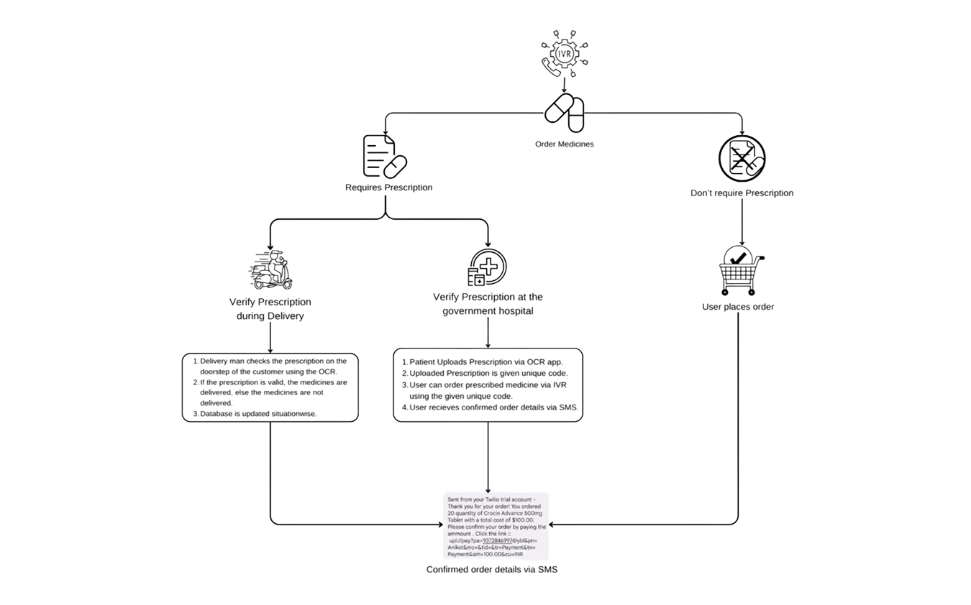

*Fig 4.2:-Detailed design*

**5. Results and Discussions**

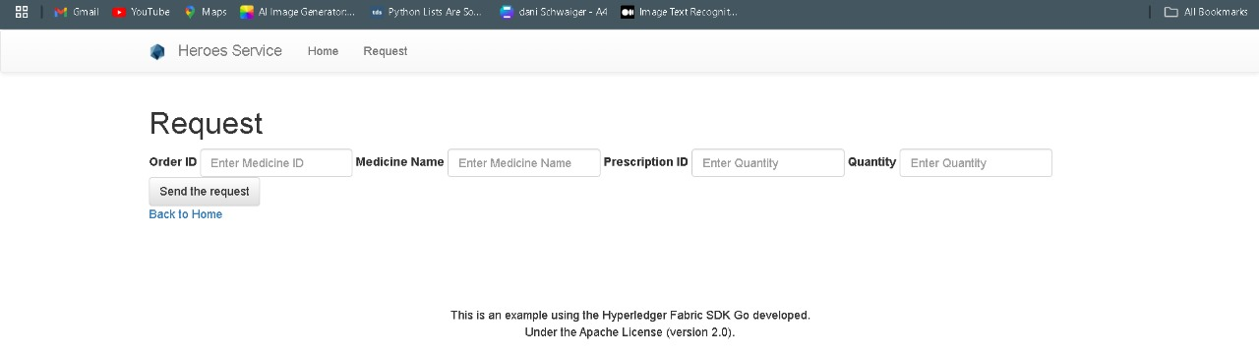

*Fig 5.1:- Chaincode Implementation*

| *Fig 5.2 Home Page*    *Fig 5.4 Fetch medicine via category*    *Fig 5.6 OCR to extract medicine names* | *Fig 5.3 Medicine Details*    *Fig 5.5 Chatbot* |
| --- | --- |

**1. IVR System’s Role in Healthcare Accessibility:**

**Use:** The IVR system was particularly impactful for non-digital users, enabling them to access essential healthcare services through a simple voice interface.

**Challenges:** Some users required initial guidance, but the system's ease of use helped overcome digital literacy barriers.

**2. OCR in Prescription Validation:**

**Use:** OCR played a key role in scanning and digitizing both existing and new prescriptions.

**Challenges:** OCR accuracy sometimes struggled with handwritten prescriptions, particularly with poor image quality. Further improvements in OCR preprocessing (such as image correction) are necessary to increase accuracy.

**3. Blockchain Ensuring Trust and Security:**

**Use:** The immutable ledger provided by blockchain ensured secure transactions and prevented prescription tampering.

**Challenges:** The scalability of the blockchain network emerged as a concern, particularly as the number of transactions increased. Optimizing consensus mechanisms and scaling the network could improve performance under high loads.

**6. Plan of action for the next semester**

**1. OCR Accuracy Improvement:**

* Focus on improving OCR accuracy for handwritten and poor-quality prescriptions by enhancing image preprocessing techniques such as contrast adjustments, noise reduction, and text orientation correction.
* Explore machine learning models that can better handle handwritten text recognition, specifically for medical prescriptions.

**2. Blockchain Scalability:**

* Investigate ways to optimize the blockchain network, especially under high transaction loads. Consider using techniques such as sharding or layer-2 scaling solutions.
* Evaluate consensus mechanisms (e.g., Byzantine Fault Tolerance or Proof of Stake) to improve transaction throughput without compromising security.

**3. AI-Assisted Prescription Validation:**

* Develop an AI-based system to assist healthcare providers in prescription validation, automating initial checks such as dosage appropriateness and prescription expiration.
* Create a rules-based engine to handle common validation tasks, reducing manual intervention and speeding up the process.

**4. Connect all components seamlessly:**

* Connect mobile application, OCR system and block chain system with each other as final product.

**7. Conclusions**

In the future, our vision is to develop a sophisticated and comprehensive Interactive Voice Response (IVR) system that transcends its current capabilities. Our goal is to create an IVR system that can not only read prescriptions accurately but also provide valuable medical advice and seamlessly place medication orders for users. We aim to leverage advanced artificial intelligence and natural language processing technologies to ensure the highest level of accuracy, user-friendliness, and reliability in the healthcare domain. This expanded IVR system will serve as a trusted healthcare companion, offering expert guidance, personalized recommendations, and a convenient platform for secure and efficient medication procurement, ultimately enhancing the well-being and health management of our users.

**8. References**

[1] N. Iqbal, F. Jamil, S. Ahmad and D. Kim, "A Novel Blockchain-Based Integrity and Reliable Veterinary Clinic Information Management System Using Predictive Analytics for Provisioning of Quality Health Services," in IEEE Access, vol. 9, pp. 8069-8098, 2021, doi: 10.1109/ACCESS.2021.3049325.

[2] S. Wang, J. Wang, X. Wang, T. Qiu, Y. Yuan, L. Ouyang, Y. Guo, and F.-Y. Wang, “Blockchain-Powered Parallel Healthcare Systems Based on the ACP Approach,” *IEEE Transactions on Computational Social Systems*, 2018, doi: 10.1109/TCSS.2018.2865526.

[3] Fan, K., Wang, S., Ren, Y. et al. MedBlock: Efficient and Secure Medical Data Sharing Via Blockchain. J Med Syst 42, 136(2018) https://doi.org/10.1007/s10916-018-0993-7

[4] A. Azaria, A. Ekblaw, T. Vieira and A. Lippman, "MedRec: Using Blockchain for Medical Data Access and Permission

Management," 2016 2nd International Conference on Open and Big Data (OBD), Vienna, Austria, 2016, pp. 25-30, doi:

10.1109/OBD.2016.11. for Informatics, Computing, and Technologies (3ICT), Sakhier, Bahrain, 2019, pp. 1-5, doi: 10.1109/3ICT.2019.8910312

[5] R. Karademir and E. Heves, "Dynamic interactive voice response (IVR) platform," Eurocon 2013, Zagreb, Croatia, 2013, pp. 98-104, doi: 10.1109/EUROCON.2013.6624972

[6] P. K. Kushwaha and M. Kumaresan, "Machine learning algorithm in healthcare system: A Review," 2021 International Conference on Technological Advancements and Innovations (ICTAI), Tashkent, Uzbekistan, 2021, pp. 478-481, https://ieeexplore.ieee.org/document/9673220

[7]Mudili Soujanya and Sarun Kumar, "Personalized IVR system in contact center" 2010 International Conference on Electronics and Information Engineering, Kyoto, Japan,2010, vol.1,no.457, https://ieeexplore.ieee.org/document/5559673/authors#authors

[8]”European Medicines Agency”, European Medicines Agency,https://www.ema.europa.eu/en/medicines/field_ema_web_categories%253Aname_field/Human , Accessed: 14 August 2023

[9]”MediSearch”,MediSearch,https://medisearch.io/, Accessed: 24 August 2023

[10]”National Library of Medicine ”,NLM Products and Services, https://eresources.nlm.nih.gov/,Accessed:14 August 2023